**Name: Shaunak Deshpande**

**Div.: TY-IC-C**

**Roll. No.: 39**

**GR no.: 11911180**

**Batch.: 2**

**LAB 1:- Process Characterization**

**Exercise 1 – Finding process gain , Dead Time , Time constant**

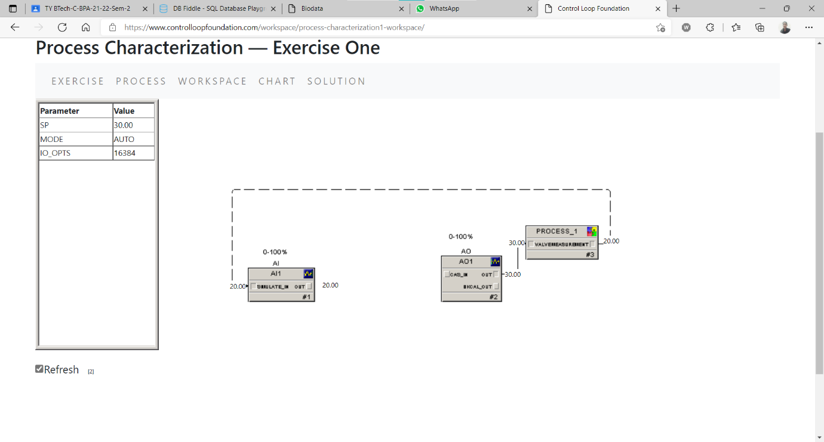

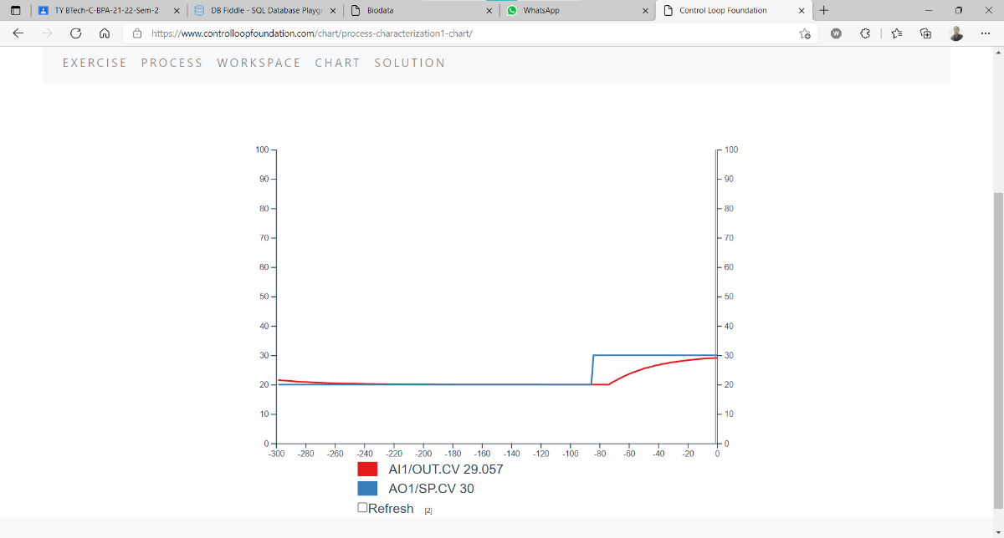

Process Gain = **O2 – O1 /I2-I1 = 1**

Dead Time = **8sec**

Time Constant = **20 sec**

**Exercise-2- Finding process gain , Dead Time , Time constant**

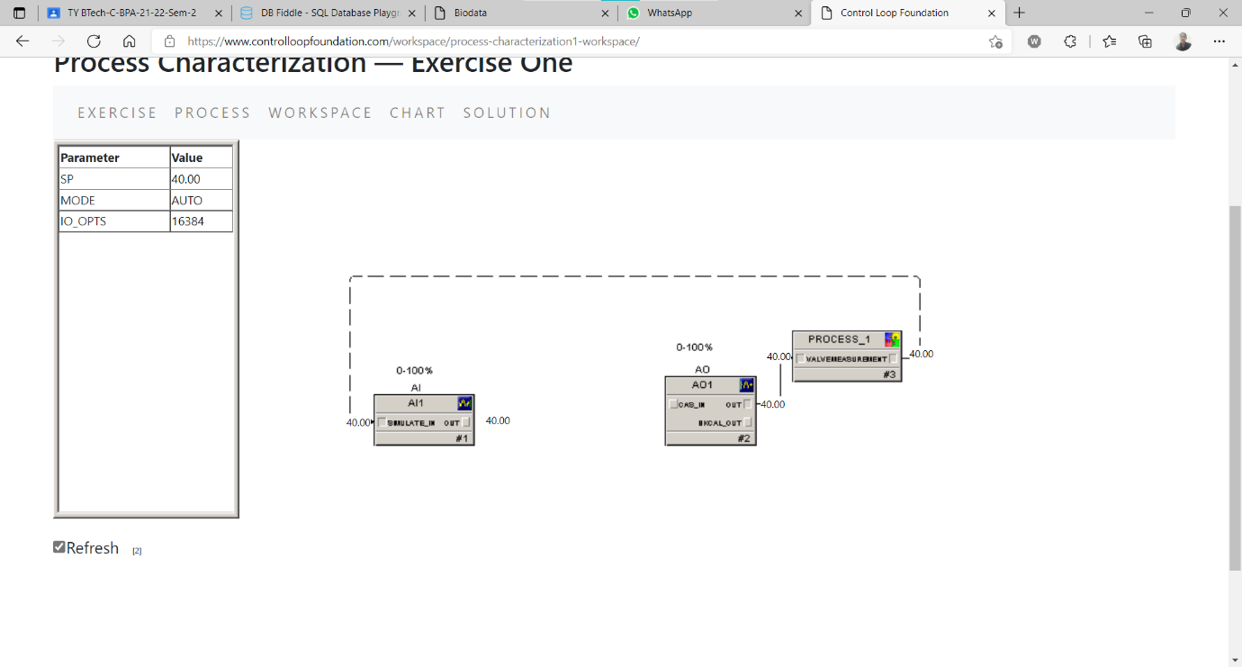

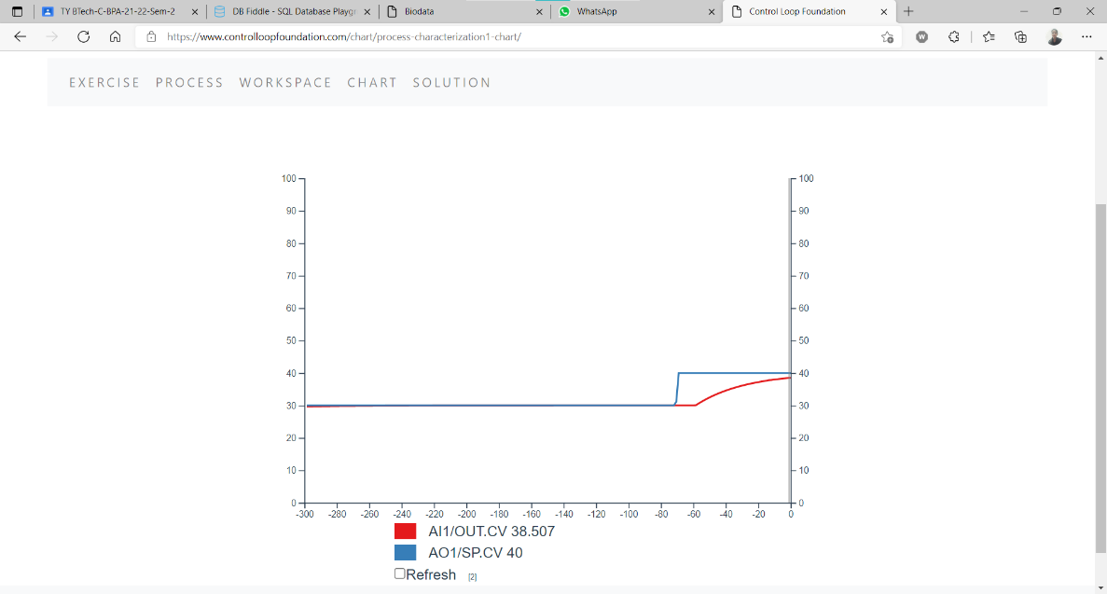

Process Gain = **O2 – O1 /I2-I1 = 1**

Dead Time = **10sec**

Time Constant = **23 sec**

**Exercise 3 – Observing system when disturbance is introduced**

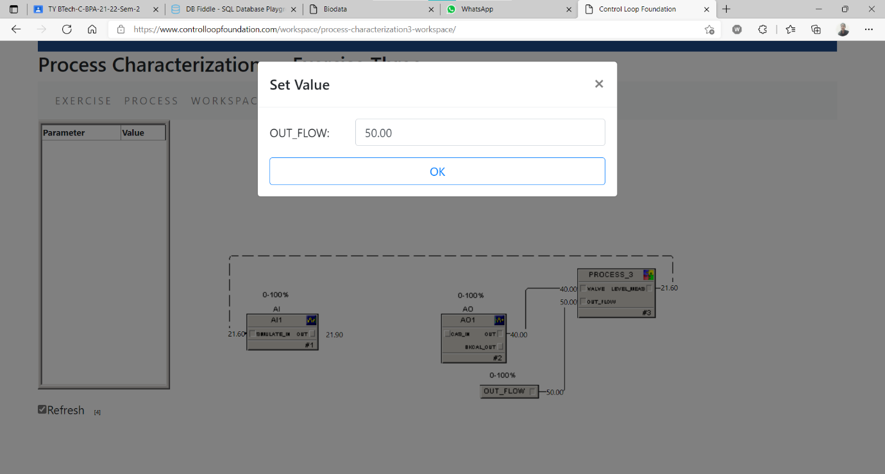

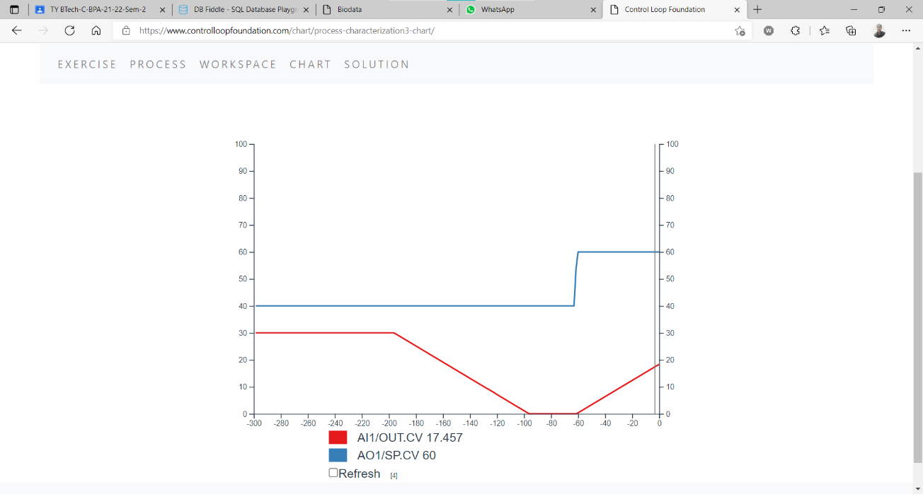

**Conclusion-**

In this Experiment, we have successfully observed Process gain, time constant and dead time of an Process Control System. We plotted the changes in these parameters and observed them, according to the Change in Set point value. We were able to calculate the values of the same through the graph.